

|  |  |  |  |  |  |  |  |  |  |  |  |
| --- | --- | --- | --- | --- | --- | --- | --- | --- | --- | --- | --- |
| |  |  | | --- | --- | | Contact | Grant Erwin, Vice President of Sales | | Telephone | (270) 813-1110 | |  |  | | Email | sales@powertecsolutions.net | | Website | www.powertecsolutions.net | | FOR IMMEDIATE RELEASEFebruary 14, 2017 |
|  |  |

PSI to unveil new rack mount smart battery At BatTcon

Integrated proactive remote management battery technology

Franklin, KY, February 14, 2017– PSI’s new rack mount smart battery has successfully been deployed in several countries to positive reviews from customers.

*Drew Hardin, Vice President of PSI (PowerTec Solutions International) states that the PSI Smart Battery is the first all-in-one solution to offer an integrated Battery Management System (BMS) to actively monitor and condition the battery, down to the cell, to ensure for optimal service life in any environment. Developed specifically for Telecom deployments, the PSI Smart Battery is also the first of its kind to provide remote monitoring and alarming, allowing Service Providers proactive visibility of the true health and status of the battery.  This visibility has been instrumental during commercial outages to remove any guesswork as to when a site may drop, giving the Service Provider all the information needed to react accordingly and prevent service outage.  The BMS works to protect and alarm against over-voltage, over-charging, and over-temperature, which are all key factors that dramatically affect the life and capacity of traditional Sealed Lead Acid batteries with no active management.*

The PSI Smart Battery is a drop-in replacement to legacy 48Vdc Sealed Lead Acid Battery strings and is very easy to install by anyone in less than 10 minutes with built in cross current protection.  The batteries also offer an environmentally safe, maintenance free design (no venting required).  Ethernet linking to the built-in battery management system is very easy to use via Cloud or SNMP Trap.

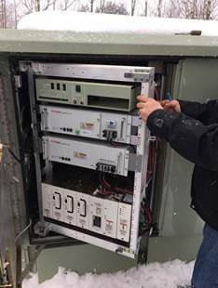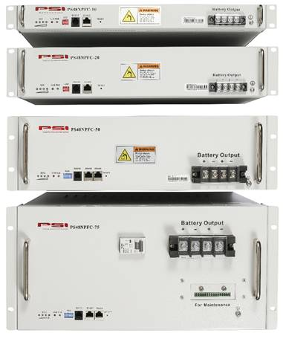

Customer Lee Cheney of Waitsfield Telecom Champlain Valley says that the six month trial install in several sites has been a success.

**PSI, (PowerTec Solutions International) is at the forefront of assisting carriers in managing backup power requirements at the customer premise and for remote hub sites. PSI has designed and manufactures the world’s smallest VDC UPS and the world’s only scalable VDC UPS. In addition to these industry leading solutions, PSI is now offering operators the ability to easily monitor PSI long life LiPH04 rack mount battery performance and backup run times from a centrally located Network Operations Center through ethernet connectivity with a user-friendly software interface.**

# # #

If you would like more information about this topic, please contact Grant Erwin, Vice President of Sales at (270) 813-1110 or email at sales@powertecsolutions.net.